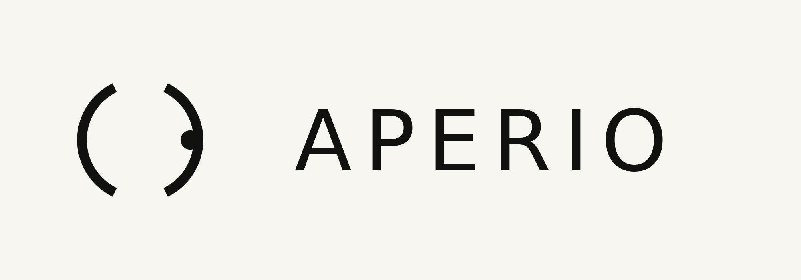
BRAND GUIDELINES
VOLUME I — STRATEGY, IDENTITY & SYSTEM
Prepared by Halide — Brand & Identity
Confidential — for client review

Contents

Right-click and “Update Field” to populate in Word.

01 — Philosophy
Every person leaves something behind: a story, a vision, a way of seeing that no one else shares. Most of that work gets presented on templates that flatten it. Aperio exists to reverse that — to take a body of creative work and give it a digital presence that carries the same precision, restraint and intent as the work itself.
We are not a web agency. A web agency ships pages. Aperio builds perception. The distinction matters: a page is a deliverable, perception is what remains in someone’s mind after they’ve closed the tab. Our clients — filmmakers, photographers, architects, designers, studios — are judged on their eye. Their website is the first place that eye is tested, before a single word is exchanged.
The website is a sign of who they are. That is the brief we hold ourselves to on every project — and it is the brief this identity had to answer for itself.

Positioning
What we are A studio that transforms creative work into a considered digital presence.
What we are not A website builder, a template marketplace, or a production house.
Who we serve Filmmakers, directors, photographers, designers, architects, studios, artists — anyone whose work rewards close looking.
The promise Your work, seen the way you intended it to be seen.

Brand personality
Six traits govern every decision in this document — from the angle of a logomark to the length of a sentence on the homepage.
- Quiet — it does not need volume to be noticed.
- Observant — it notices what others miss, and says so plainly.
- Precise — nothing is approximate; every measurement has a reason.
- Curious — genuinely interested in how things are made.
- Elegant — restraint used as a form of respect for the work it frames.
- Bold without shouting — confident in silence, never in volume.

02 — The Hidden Concept: Vision
Every mark in this identity is built on a single word the audience is never told: vision. Not an eye — that was ruled out on day one, along with any literal camera, shutter or lens icon a competitor would reach for first. Instead, the mark had to earn the idea of vision through geometry: observation, focus, depth, presence — discovered on second look, never announced on first.
This is the same discipline behind the reference marks in our brief — the arrow hidden in FedEx’s negative space, the ear implied in Beats’ silhouette, the forward motion compressed into Notion’s ‘N’. None of these explain themselves. They reward attention, which is precisely the currency our clients trade in.

The design rules we held ourselves to
- No pupil, no iris, no lashes, no shutter — anything that reads as a literal eye on first glance is disqualified.
- The eye arrives as a discovery — through negative space, overlap, or a line that implies a lid without drawing one.
- The geometry must survive at 16 pixels. If the secret only works at poster scale, it is an illustration, not a logo.
- Every concept must resolve in a single ink colour — the true test of whether a mark is built on structure or decoration.

The name
APERIO is Latin: to open, to uncover, to reveal. It is the root behind ‘aperture’ — the opening in a lens that governs how much light, and how much truth, gets through. The name does the same work as the mark: it sounds architectural and international, it never once says ‘eye’, and it gives every piece of copy in this document a verb to build around — reveal, open, uncover, expose. That verb is the brand’s engine.

03 — The Logomark
The mark is built from two facing arcs, left deliberately open, with a single point resting just outside the gap. It is a viewfinder bracket softened into a circle — the exact place a camera sets its focus indicator is the exact place an eye rests its gaze. Vision, again, arrives as a discovery rather than an illustration.

Hidden meaning Two arcs face each other with a deliberate gap — a viewfinder bracket, softened — and a single point sits just outside the open edge: the exact place a camera places its focus indicator, and the exact place an eye rests its gaze.
Geometry Two 164° arc-ribbons of equal stroke weight, mirrored around the centre, with a filled circle positioned at 0.86r along the open axis.
Philosophy The most minimal expression of the brief — it says ‘focus’ rather than ‘eye’, an abstract nod to attention and precision that never once illustrates a camera or an eye directly.
Scalability Extremely robust at any size because it is built from only two shapes: two arcs and a dot resolve cleanly from a 4K title card down to a 16px favicon without losing the gap or the point.

04 — Construction & Application
The mark above is the single logomark carried through every application in this document — digital, print, and physical. What follows is how it is built, sized, and protected.

Primary lockup — mark and wordmark, light application
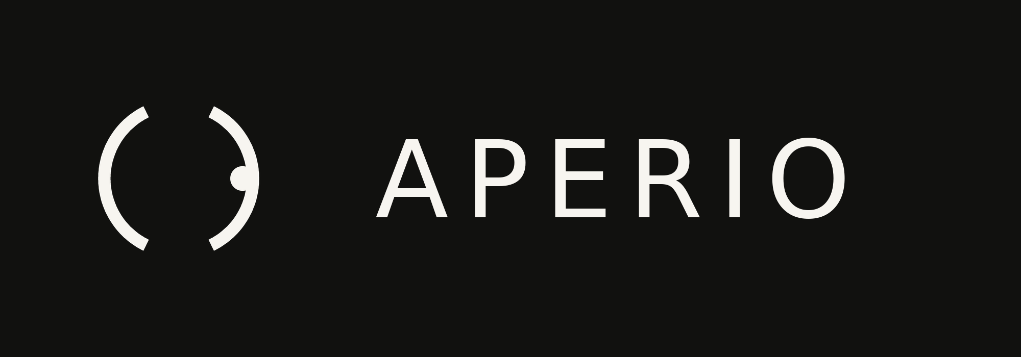
Primary lockup — dark application

Construction & clear space
Minimum clear space around the mark, on all sides, is equal to the width of the gap between the two arcs. Nothing — text, edge of frame, other marks — enters that space.

Minimum size
- Digital: 16px (favicon) as a solid mark; 24px minimum when paired with the wordmark.
- Print: 6mm mark height minimum; below that, use the mark alone without the wordmark.

Icon & favicon

App icon, dark tile

Misuse
- Never close the gap between the two arcs — the opening is the point of focus, not an oversight.
- Never remove or resize the focal dot independently of the arcs; it is fixed at 0.86r along the open axis.
- Never place the mark on a busy photograph without a solid-colour holding shape beneath it.
- Never rotate, skew, or add a drop shadow, gradient fill, or bevel to the mark.
- Never recreate the mark with a literal pupil, iris, or camera lens added — it defeats the entire premise of the identity.

05 — Colour System
The palette is deliberately narrow. A brand that asks people to look closely should not compete for attention with its own colour system — every hue earns its place, and the one warm accent is spent sparingly enough that it still means something when it appears.
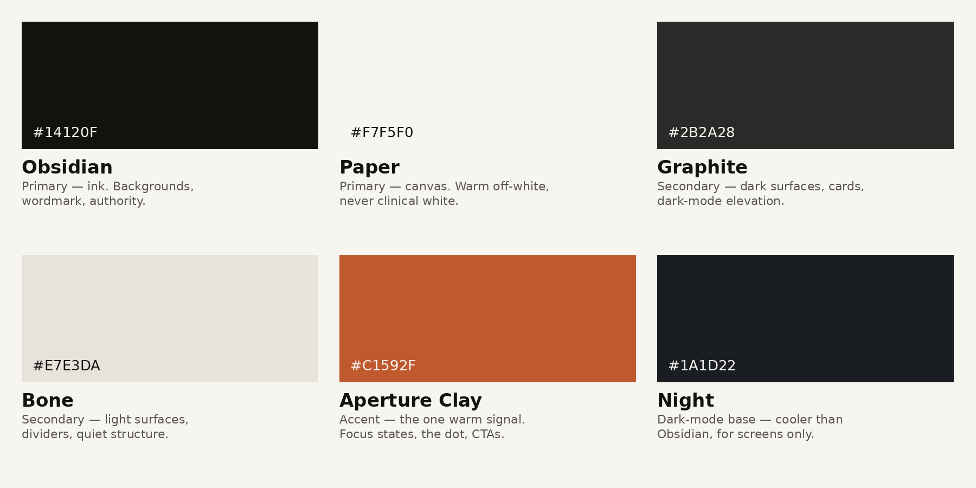

Usage ratios
60% — Paper or Obsidian the dominant field, chosen per light/dark mode.
30% — Bone or Graphite secondary surfaces — cards, dividers, quiet structure.
10% — Aperture Clay reserved for the one signal that should never be missed: focus states, the mark's own focal dot, primary calls to action.

Light mode
Background Paper (#F7F5F0), text Obsidian (#14120F), structure Bone (#E7E3DA). Warm off-white rather than clinical white — clinical white photographs poorly against the black-and-white work our clients tend to upload as hero imagery.

Dark mode
Background Night (#1A1D22) rather than true black — true black crushes shadow detail in the film stills and night photography this audience frequently showcases. Text Paper (#F7F5F0), structure Graphite (#2B2A28).

06 — Typography
Recommended production faces: Neue Haas Grotesk Display (headings) paired with a text-optimised grotesk such as Suisse Int’l or Inter (body) — Swiss-rooted, precise, without personality loud enough to compete with client photography. Specimens below are set in a system substitute for this document only.
Level | Weight / Size | Use
Display | Light, 64–96pt, tight tracking | Homepage headline, section openers — one line only, never wraps
Heading | Regular, 28–40pt | Project titles, section labels
Body | Regular, 16–18pt, 1.5 line height | All reading copy — optimised for long, unhurried paragraphs
Caption | Regular, 12–13pt, uppercase, tracked | Image credits, metadata, dates
Numerals | Tabular lining figures | Project numbers, years, dimensions — always tabular so columns align
Button / UI | Medium, 13–14pt, uppercase, +6% tracking | Interactive labels only — never used for reading copy

Hierarchy principle
Weight, not size, does most of the work. A Display line at 72pt Light sits quietly next to Body copy because the contrast is in the stroke, not the scale — this is what keeps the system feeling architectural rather than shouty.

07 — Brand System

Grid
A 12-column grid at desktop (72px columns, 24px gutter), collapsing to 4 columns on mobile. Every image, whether a client’s photograph or our own UI element, aligns to this grid — nothing floats free of structure, because structure is the whole point of the brand.

Spacing
An 8pt base unit (4pt for optical corrections only). Section spacing is always a multiple of 8: 8, 16, 24, 32, 48, 64, 96, 128. This scale is the single most-referenced rule in the system — it is what makes every screen we ship feel like it belongs to the same family.

Corner radius
2px on UI controls (buttons, inputs, tags) — enough to soften without softening the architecture. 0px on all image containers and cards; client photography is never given rounded corners, which is the one rule every collaborator asks about and the one we never bend, because a rounded frame around someone’s photograph editorialises it in a way that isn’t ours to do.

Icon style
1.5px stroke, no fill, 90° and 45° angles only, rounded caps. Icons are functional signage, not decoration — they should read as instructions, never as illustration.

Photography direction
- We never generate or stage photography of our own — the client’s work is always the subject.
- Our own supporting imagery (case study intros, about pages) is restricted to architectural negative space: doorways, thresholds, apertures, corridors — literal vision metaphors kept entirely out of frame from any client work.
- High contrast, desaturated, natural light preferred over studio lighting.

Art & illustration direction
No illustration beyond the logomark system itself. Where a diagram is unavoidable (a process page, a pricing table), it is built from the same arc-and-dot vocabulary as the mark — the identity should never need a second visual language.

Texture & pattern
A single supporting pattern exists: the mark tiled at 4% opacity as a watermark on cover sheets and PDF exports only — never on-screen, where it would compete with client work.

08 — Motion Identity

Logo reveal (2.4s)
The two arcs draw in from opposite sides over 900ms (ease: cubic-bezier(0.22, 1, 0.36, 1) — a slow, confident deceleration, never a bounce), closing to their resting gap but never sealing it. At 1100ms the arcs settle and hold, still, for 400ms — a held breath. At 1500ms the focal dot drops into place at the open edge with a single 250ms settle. The wordmark fades in beneath over the final 650ms. Nothing moves after 2.4s.

Principles
- Ease out, never bounce — bounce reads as playful; this brand reads as certain.
- One motion at a time — elements never animate simultaneously unless they are the same gesture (e.g. the two arcs drawing in together).
- 400–600ms for UI transitions; 900ms+ reserved for hero/brand moments only.

Micro-interactions
- Hover states shift opacity, never scale — nothing on the canvas should feel like it is reaching toward the cursor.
- The accent Clay appears only on focus and active states — it is the system’s single ‘you are here’ signal.
- Page transitions are cross-fades at 400ms; no slides, no wipes, no parallax — motion should never upstage the work being presented.

09 — Brand Applications
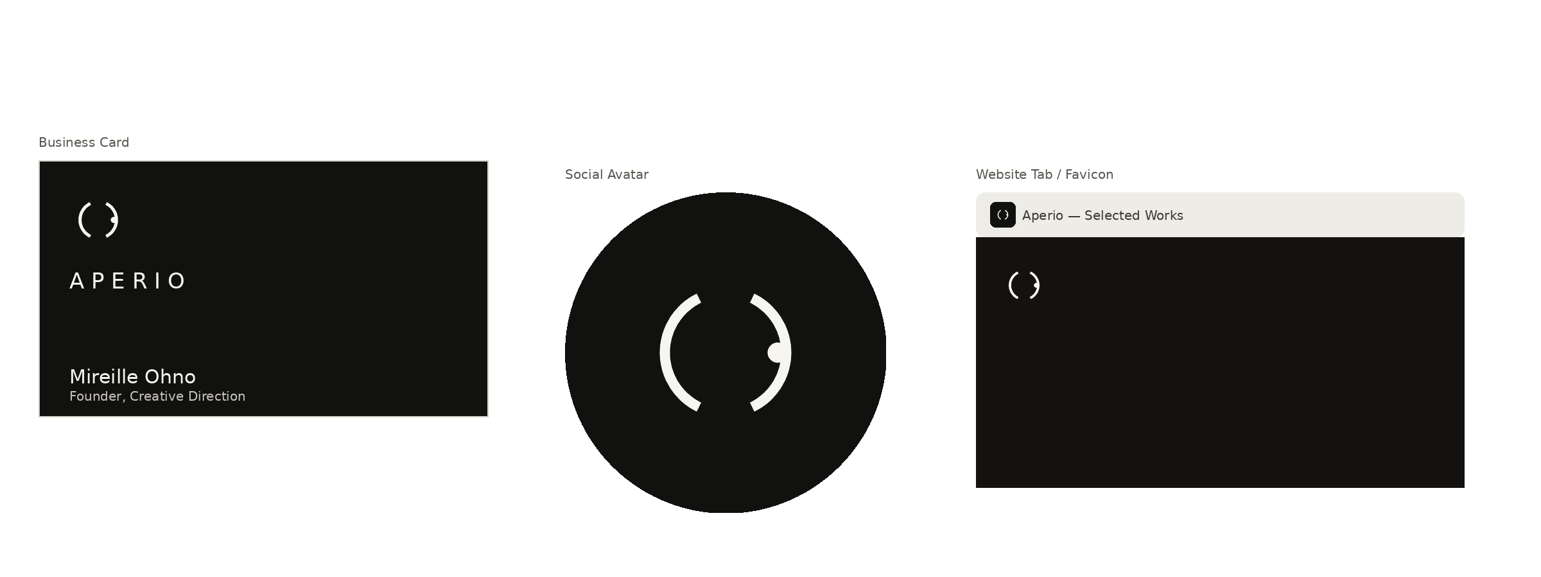
Business card, social avatar, and browser tab / favicon in application

Website & portfolio
Full-bleed client imagery, generous negative space, Display headline set in a single line. Navigation is text-only, no icons — the mark appears exactly once, in the header, at minimum size.

Business card
Mark and wordmark on the front in Paper-on-Obsidian; name and role only on the reverse, set in Body weight. No email, phone, or address — those live on the site, reachable by a QR resolving to the mark itself.

Presentation & invoice
Both use the same cover treatment: Obsidian field, mark top-left at minimum clear space, Display title, Caption-weight metadata (date, project number, tabular figures) bottom-right.

Social media
Avatar is the app icon cropped to a circle (shown above) — never the full lockup, which loses legibility at avatar scale. Cover images follow the photography direction in Section 07: architectural negative space only, no client work used as brand-channel wallpaper.

Packaging, sticker, notebook, t-shirt, signage
- Packaging (presentation boxes for printed portfolios): Obsidian stock, mark foil-stamped in Clay — the only application where the accent colour is used at this scale.
- Laptop sticker: mark alone, die-cut to the outline of the two arcs and the dot rather than a rectangle — the shape is the sticker.
- Notebook: mark blind-embossed (no ink) on Bone stock — legible only by shadow and touch, the most literal expression of ‘discovered on second look’ in the entire system.
- T-shirt: mark only, small, left chest, Paper ink on Graphite fabric — never the wordmark, and never larger than a business card.
- Signage (studio entrance, event step-and-repeat): mark and wordmark at large scale are the one context where the arcs may be milled or routed at increased weight and the dot fabricated as an inset disc, for structural visibility — the only sanctioned exception to the construction spec in Section 04.

10 — Taglines
01 Seen, before a word is spoken.
02 The work speaks first.
03 Presence, engineered.
04 What you make, made visible.
05 Not a website. A vantage point.
06 Every portfolio is a first impression — make it unforgettable.
07 We build the moment before ‘wow.’
08 Vision, structured.
09 Your work, uncovered.
10 The frame before the frame.
11 Quiet confidence, rendered.
12 Look closer.
13 Where craft becomes perception.
14 The first thing they notice. The last thing they forget.
15 Built for the way you see.
16 A portfolio should feel like a held breath.
17 Precision is the loudest thing we say.
18 Some sites are seen. Ours are felt.
19 The eye finds what the work deserves.
20 Aperio: to open, to reveal.
21 Your perspective, finally visible.
22 Nothing decorative. Everything intentional.
23 We don’t decorate work. We reveal it.
24 Make the first impression the right one.
25 Design that watches back.
26 Every pixel earns its place.
27 Presence before introduction.
28 The site remembers what words forget.
29 Focus is a form of respect.
30 What you see is what you’ve built.

11 — Voice & Tone
Aperio writes the way it designs: short sentences, no exclamation points, no hype adjectives. The voice reads like wall text in a gallery — it tells you exactly what you are looking at and then gets out of the way.

Principles
- Declarative over persuasive — state the fact, trust the reader to draw the conclusion.
- One idea per sentence. If a sentence needs a comma to hold two ideas, it becomes two sentences.
- Verbs from the name’s own root — reveal, open, uncover, expose — recur naturally rather than as a gimmick.
- Never ‘amazing,’ ‘stunning,’ or ‘game-changing’ — the work is the amazing part; the brand does not need to say so.

Headline style
Headlines are short, sentence-case (never title case), and end without punctuation. Example: ‘Your work, seen the way you intended it to be seen’ — not ‘Your Work, Seen The Way You Intended It To Be Seen!’

Do / Don’t
- Do: ‘We build the moment before the click.’ Don’t: ‘We create AMAZING first impressions that WOW your visitors!’
- Do: ‘Your portfolio, live in six weeks.’ Don’t: ‘Get your dream website faster than ever before!!’


Your work, seen the way you intended it to be seen.
Halide — Brand & Identity

